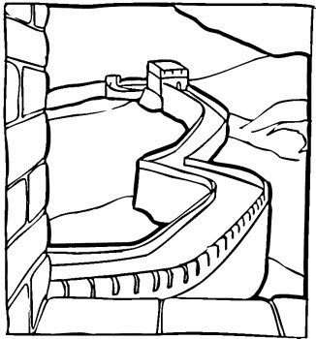
Virtual Field Trip to the Great Wall China

Go to the link and take a virtual tour of the Great Wall of China!
http://www.thechinaguide.com/index.php?action=activity/greatWallOfChina
Be sure to look at all three views by clicking on the button.

Watch and consider the following questions. Talk with your group about your guesses.
- What would the watch tower be used for?
- What would the openings on the bottom of the walls be for?
- What purpose would the openings at the top of walls serve?
- What were the openings in the middle of the wall be for?
- What was the raised areas for?

After you have looked around and talked about the questions go to the following
Link and read though the one page together.

http://www.travelchinaguide.com/china_great_wall/construction/wall/

Read through the wall construction from the link above and see if you can answer the above questions. Did you guess right?
Record the correct answer for 1-4 on your paper as well as the following questions.
- Why was the wall built taller in certain areas?
- Approximately how tall is the Great Wall?

